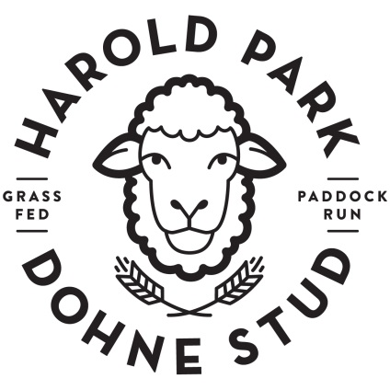
Harold Park Dohne Order Form

Name__________________________________________
Phone__________________________________________
Email ___________________________________________
Please note that in the instance of flavoured items such as sausages and ribs, flavours may vary from month to month.
Email this form to haroldparkdohne@bigpond.com to place your order.
Cut | Price/kg  (as of 19/9/18) | Roughly how much or how many
Loin Chops | 24.99
Crumbed cutlets | 32.99
French cutlets | 34.99
French racks | 34.99
Leg Roast | 14.99
Leg Roast – easy carve | 18.99
Neck Chops | 7.99
Shanks | 14.99
Burger patties | 14.99
Gourmet sausages | 16.99
Steaks | 24.99
Mince | 16.99
Diced | 24.99
Skewers | 12.00 (2/ea)
Boned &Rolled Forequarter Roast | 19.99
Butterfly leg (chilli and garlic) | 19.99
Marinated ribs | 14.99
Lamb’s fry | 4.00 ea
Heart & kidney combo | 4.00 per tray
Whole carcass | Please ask for info
Half carcass | Please ask for info

